Brief summary about the project
URN and project name: | AP08856925 "Neolithic of North-Eastern Kazakhstan"
Implementation Timeline: | 01.10.2020-31.12.2022
Relevance: | The project is aimed at studying the Neolithic monuments of Northeast Kazakhstan, and is a new stage in the formation of the source base of a separate part of the vast steppe region. The obtained material will become the basis for further step-by-step study of separate periods of the Neolithic epoch of the whole Northern and Eastern Kazakhstan.
Goal: | Determination on the basis of characterization of material culture of chronological stages and interaction between different cultural groups that existed in the north-eastern regions of Kazakhstan, their place among synchronous formations of Northern Eurasia in the Neolithic era (VI - beginning of IV millennium BC) with the help of new archaeological materials. The main research takes place in the territory of the Irtysh area within the limits of Pavlodar region and adjacent to it from the south-east of the East Kazakhstan region (Beskaragai district and the territory subordinated to the akimat of Semey city).
Expected and achieved results: | 1. Collection of all available information on monuments and accidental finds of the Neolithic period of the studied region, as well as identification of new basic archaeological sites. Formation of a well-documented set of sources.  2. Characterization of the material culture of the Neolithic period of the region (identification of ceramic traditions, characterization of stone industry, art, and economy).  3. Determination of cultural affiliation and chronology of archaeological monuments of the Neolithic era, the presence of kinship or its absence. Determination of the distribution areas of the identified cultural formations of the region.  4. Consideration of the questions of genesis, interrelations of ancient population on the designated territory, revealing the role of migrations, assimilations, cultural innovations and traditions in these processes.  Achieved results  1) all available information about Neolithic monuments of the north-eastern regions of Central Kazakhstan has been supplemented;  2) new monuments were discovered, field studies were conducted, as a result of which material for natural science research was obtained;  3) the results of research are partially presented to the scientific community.  1. Vartholomeev V.V., Mertz V.K., Mertz I.V. Shokpartas - a new Eneolithic monument of the Central Saryarka // Bulletin of L.N. Gumilyov Eurasian National University. Series Historical Sciences. Philosophy. Religious Studies. № 1(134). 2021. С.36-48.  2. Mertz V.K. K question about cultural and historical processes in the Neolithic of North-Eastern Kazakhstan and adjacent regions // Archaeology of North and Central Asia: new discoveries and results of interdisciplinary studies: collection of articles dedicated to the 75th anniversary of Y.F. Kiryushin. Barnaul: Izd-Vo-Alt. Usta, 2021. С. 102-112.  3. Pablo Librado, ... Merts V., Merts I., ... , Ludovic OrlandoThe origins and spread of domestic horses from the Western Eurasian steppes // Nature. October 20, 2021. https://doi.org/10.1038/s41586-021-04018-9  4. Merts V.K. About complexes of the pre-Botay type of Northern Kazakhstan // Bulletin of L.N. Gumilyov Eurasian National University. Series Historical Sciences. Philosophy. Religious Studies (in press).  5. Mertz I.V., Rogozhinsky A.E., Mertz V.K. Kenzhebai - a new multi-temporal settlement in the Buguly mountain massif // BULLETIN of L.N. Gumilyov Eurasian National University. Series Historical Sciences. Philosophy. Religious Studies (in press).  6. Mertz V.K., Usmanova E.R. "The pattern "space of the living for the dead": from Eneolithic to Nomads (on the materials of settlements of Eastern Saryarka and Irtysh Land)" // "Space not only for the living: Human remains at BronzeAge set-tlements in Eurasia" (in press).  7. Mertz V.K. Some results of the study of archeological monuments of Beskaragai district and prospects for further research of the North-Western part of the East-Kazakhstan region // Actual problems of historical local lore: modern approaches and views. Materials of the republican scientific-practical conference "II Kasymbayev readings" devoted to the 30th anniversary of independence of the Republic of Kazakhstan (in press).
Composition of the research team
(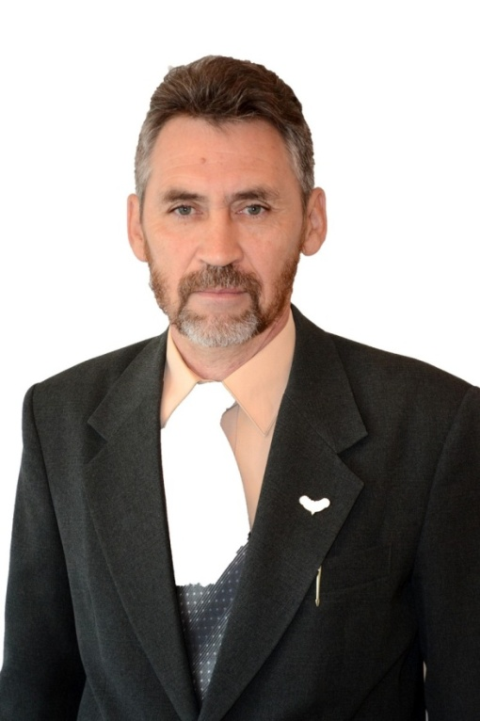 | Mertz Viktor Karlovich
 | Scientific supervisor of the project
 | Date of Birth: 30.11.1962
 | Candidate of Historical Sciences, Professor
 | Margulan Center for Archaeological Research, Toraighyrov University
 | Research interests: Stone Age and primitive archaeology in general, problems of anthropogenesis and culturogenesis, origin of art.
ResearcherID *O-1119-2019
https://publons.com/researcher/2921917/viktor-k-merts/
ScopusAuthorID*57200799329
https://www.scopus.com/authid/detail.uri?authorId=57200799329
ORCID*0000-0003-3163-1609
https://orcid.org/0000-0003-3163-1609
Main scientific achievements: For more than thirty years conducts independent archaeological research on topics related to the ideas of the project, author and co-author of more than 100 works on the archaeology of Kazakhstan. One of the authors and compilers of the "Code of monuments of Pavlodar region", which included information about more than 600 monuments of archeology of different periods. Results of scientific activity are reflected in a number of publications. Hirsch index 5. He is the largest domestic specialist in the field of archeology of the Stone Age and transitional from the Stone Age to the Bronze Age period.
Articles in the publication included in the Skopus list:
1) Gaunitz Ch., … V. Merz, Merz I., …Orlando L. Ancient genomes revisit the an cestry of domestic and Przewalski’shorses // Science. Vol. 360. Issue 6384. PP. 111-114. http://science.sciencemag.org/content/early/2018/02/21/science.aao3297
2) de Barros Damgaard P., … Merz V., Merz I. …, Durbin R. The first horse herders and the impact of early Bronze Age steppe expansions into Asia // Science. Vol. 360. Issue 6396.http://science.sciencemag.org/content/early/2018/05/08/science.aar7711
3) de Barros Damgaard P., ... Mertz I. V., Mertz V. K., ...Willerslev E.137 ancient human genomes from across the Eurasian steppes // Nature (2018) https://doi.org/10.1038/s41586-018-0094-2
4) MűhlemannB.,…Merz V.,…WillerslevE.Ancient hepatitis B viruses from the Bronze Age to the Medieval period // Nature (2018) https://doi.org/10.1038/s41586-018-0097-z
5) Pablo Librado, … Merts V., Merts I., … , Ludovic OrlandoThe origins and spread of domestic horses from the Western Eurasian steppes // Nature. 20 October 2021. https://doi.org/10.1038/s41586-021-04018-9
Monographs:
1) Merts V. K. A brief history of the development of material culture of Pavlodar Irtysh Land: illustrated popular science edition. Pavlodar, 2019. 142 p.
 | Ilya Viktorovich Merts
 | Research Associate
 | Date of birth: 22.11.1987
 | Candidate of Historical Sciences
 | Researcher of the Margulan Center for Archaeological Research, Toraighyrov University
 | His research interests include archaeology of the Bronze Age of Northern Eurasia, in particular the problems of culturogenesis, pottery, formation of metallurgy and mining in the Bronze Age.
 | ResearcherID * W-2579-2017 https://publons.com/researcher/1993644/ilja-ivm-merts/
 | ScopusAuthorID* 56866320100 https://www.scopus.com/authid/detail.uri?authorId=56866320100
 | ORCID* 0000-0001-9066-9629 https://orcid.org/0000-0001-9066-9629
Author of 30 scientific works published in scientific editions of Kazakhstan and Russia. Participant of a number of research projects of the Russian Foundation for Scientific Research and the Ministry of Science and Education of the Republic of Kazakhstan, as well as complex archaeological expeditions in Kazakhstan, Mongolia and Russia.
Articles in the publication included in the Skopus list:
1) Gaunitz Ch., … V. Merz, Merz I., …Orlando L. Ancient genomes revisit the an cestry of domestic and Przewalski’shorses // Science. Vol. 360. Issue 6384. PP. 111-114. http://science.sciencemag.org/content/early/2018/02/21/science.aao3297
2) de Barros Damgaard P., … Merz V., Merz I. …, Durbin R. The first horse herders and the impact of early Bronze Age steppe expansions into Asia // Science. Vol. 360. Issue 6396.http://science.sciencemag.org/content/early/2018/05/08/science.aar7711
3) de Barros Damgaard P., ... Mertz I. V., Mertz V. K., ...Willerslev E.137 ancient human genomes from across the Eurasian steppes // Nature (2018) https://doi.org/10.1038/s41586-018-0094-2
4) Librado, P., Khan, N., Fages, A., ...Outram, A., Orlando, L. The origins and spread of domestic horses from the Western Eurasian steppes
Nature, 2021, 598(7882), стр. 634–640
99-й percentile https://www.scopus.com/sourceid/21206#tabs=1
Articles in publications included in the list of CQAE RK:
1) Omarov G.K., Besetaev B.B., Mertz I.V., Sagyndykova S.T. Brief report on the results of archaeological survey in the territory of Kurchum district in 2018 // Bulletin of Al-Farabi Kazakh National University. Series historical. № 4 (91). 2018.С. 201-213.
2) Merts I.V. The most ancient wheeled transportation of East Kazakhstan. //Electronic scientific journal "edu.e-history.kz"
http://edu.e-history.kz/kz/publications/view/1029.
3) Mertz I.V., Antonov M.A. Grotto Enbek with rock paintings in the vicinity of Taldykorgan // Otantarikhi, № 2 (86), 2019. С. 200-214.
4) Vartholomeev V.V., Mertz V.K., Mertz I.V. Shokpartas - a new Eneolithic monument of the Central Saryarka // VESTRIC of L.N. Gumilyov Eurasian National University. Series Historical Sciences. Philosophy. Religious Studies. № 1(134). 2021. С.36-48.; DOI: https://doi.org/10.32523/2616-7255-2021-134-1-36-48

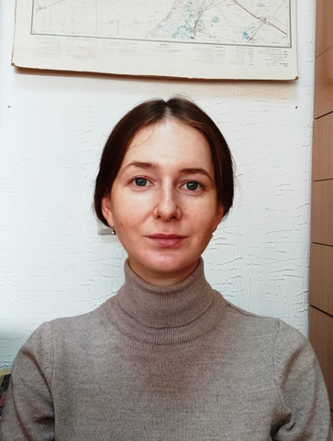 | Lyalina (Demidkova) Elena Danilovna
 | Research Associate
 | Date of birth: 03.05.1996
 | Master of Archaeology and Ethnology
 | Junior Researcher of the Margulan Center for Archaeological Research, Toraighyrov University
 | Area of expertise: archaeology
More than 10 scientific publications, including the most significant ones:
1) Comparative analysis of stone industry of Kostomar settlement and Chernoozerie VIa site // Proceedings of the Russian (with international participation) archaeological and ethnographic conference of students, undergraduates, graduate students and young scientists (RAESC-58), Omsk, 2018.
2) On specifying the location of some archaeological monuments of Pavlodar Irtysh Land // Tarih ğylymdarynyñ doktory, profesor Kadysova Roza Jūmabaiqyzyn eske aluğa arnalğan «Tarih ğylymy «Ruhani jañğyru» mänınde» atty Respublikalyq ğylymi-täjıribelık konferensiasynyñ materialdary / Toraighyrov University. - Pavlodar, 2018. - VOL. 2. - P. 271-274.
3) Archaeological research in the mountains Kalmakkyrgan (Mayskiy district of Pavlodar region)/ Mertz V.K, Mertz I.V. // Margulanovskie readings - 2020: materials of the international scientific-practical conference "Great Steppe in the light of archaeological and interdisciplinary research" (Almaty, September 17-18, 2020). Almaty: Institute of Archaeology named after A.H. Margulan. A.H. Margulan, 2020. Т. 2. P. 483-497.

 | Volkova Nadezhda Valeryevna
 | Junior researcher
 | Date of birth: 08.01.1970
 | Master of Pedagogical Sciences, specializing in pedagogy and psychology
 | Researcher of the Margulan Center for Archaeological Research, Toraighyrov University
 | Research interests design, art, photography, ceramics, archaeological drawing
 | Member of the Eurasian Union of Designers and the Union of Designers of Irtysh Land.

